Book

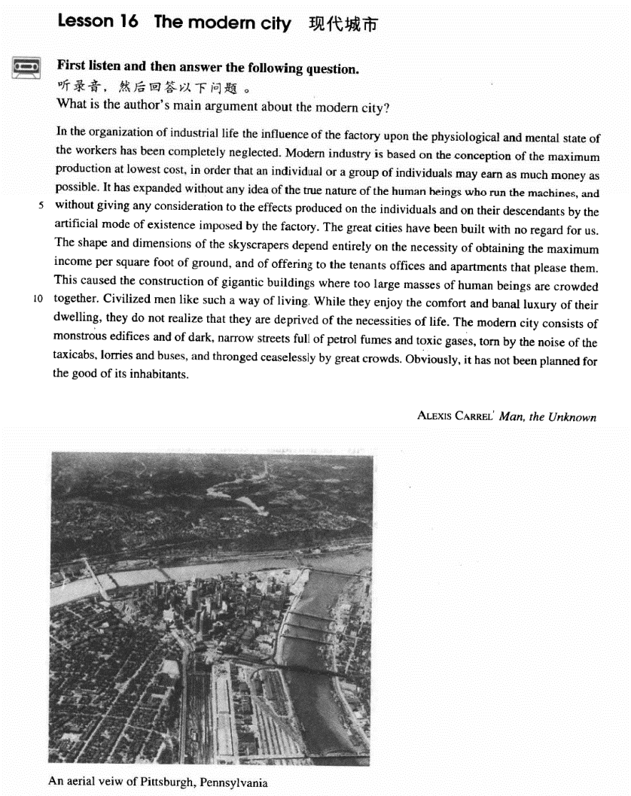

课文

In the organization of industrial life the influence of the factory upon the physiological and mental state of the workers has been completely neglected.

在工业生活的组织中，工厂对工人的生理和精神状态的影响完全被忽视了。

Modern industry is based on the conception of the maximum production at lowest cost, in order that an individual or a group of individuals may earn as much money as possible.

现代工业的基本概念是：以最低成本获取最多产品，为的是让某个个人或某一部分人尽可能多地赚钱。

It has expanded without any idea of the true nature of the human beings who run the machines,

现代工业发展起来了，却根本没想到操作机器的人的本质。

and without giving any consideration to the effects produced on the individuals and on their descendants by the artificial mode of existence imposed by the factory.

工厂把一种人为的生存方式强加给工人，却不顾及这种生存方式给工人及其后代带来的影响。

The great cities have been built with no regard for us.

大城市的建设毫不关心我们。

The shape and dimensions of the skyscrapers depend entirely on the necessity of obtaining the maximum income per square foot of ground, and of offering to the tenants offices and apartments that please them.

摩天大楼完全是按这样的需要修建的：每平方英尺地皮取得最大收入和向租房人提供使他满意的办公室和住房。

This caused the construction of gigantic buildings where too large masses of human beings are crowded together.

这样就导致了许多摩天大厦拔地而起，大厦内众多的人挤地一起。

Civilized men like such a way of living.

文明人喜欢这样一种生活方式。

While they enjoy the comfort and banal luxury of their dwelling, they do not realize that they are deprived of the necessities of life.

在享受自己住宅的舒适和庸俗的豪华时，却没有意识到被剥夺了生活所必需的东西。

The modern city consists of monstrous edifices and of dark, narrow streets full of petrol fumes and toxic gases, torn by the noise of the taxicabs, lorries and buses, and thronged ceaselessly by great crowds.

大得吓人的高楼和阴暗狭窄的街道组成了今日现代化的城市。街道上充斥着汽油味和有毒气体，出租汽车、卡车、公共汽车的噪音刺耳难忍，络绎不绝的人群挤来挤去。

Obviously, it has not been planned for the good of its inhabitants.

显然，现代化的城市不是这居民的利益而规划的。

词汇讲解

**Lesson 16 The modern city** consideration [kən7sɪdə'reɪʃn]

n.考虑

Please give careful consideration to the question. The plans merit / deserve serious consideration. There are several amendments under consideration. It is a matter beneath consideration.

take … into consideration / account

descendant [dɪ'sendənt]

n. 后裔，子孙

He is a direct descendant of Confucius. offspring

conflicts between parents and their offspring posterity

These works of art are preserved for posterity. ancestor

forefather forebear

predecessor successor

Bill Clinton is George W. Bush’s predecessor.

George W. Bush is Bill Clinton's successor.

descend ascend

in descending order in ascending order

be descended from …

We are all descended from Yandi and Huangdi. We are all descendants of Yandi and Huangdi. condescend

The general condescended to dine with the soldiers. transcend

The best movies are those which transcend national and cultural barriers. artificial [7ɑ:tɪ'fɪʃl]

adj. 人工的，人造的，假的

artificial flowers / limbs / intelligence (AI) / respiration

synthetic

synthetic fibers / rubber

simulated

simulated fur / jewels

false

false hair / teeth

fake / counterfeit

fake / counterfeit money forged

a forged signature pirated

pirated CDs / books / software

impose [ɪm'pəʊz]

n. 强加

impose / force sth. on / upon sb.

Some parents impose / force their own moral values on their children.

It was not forced upon them by the survival competition; they could have caught and lived on prey without using poison, just as the thousands of non-poisonous snakes still do.

Advertising exerts a subtle influence on us. exert sth. on / upon sb.

My wife exerts a lot of pressure on me to make more money. inflict sth. on / upon sb.

He always inflicts his company on me. Please don’t inflict your love on me.

impose expose propose

oppose dispose interpose

|  |  |  |
| --- | --- | --- |
| depose | compose | decompose |
| transpose | juxtapose |  |
| dimension |  |  |

[daɪ'menʃn] [dɪ'mɛnʃən]

n. 空间的量度

Please specify the dimensions of your room.

(the length, the width and the height of your room) three-dimensional

the fourth dimension skyscraper ['skaɪskreɪpə(r)]

n. 摩天大楼skyscraper high-rise

edifice edify mansion

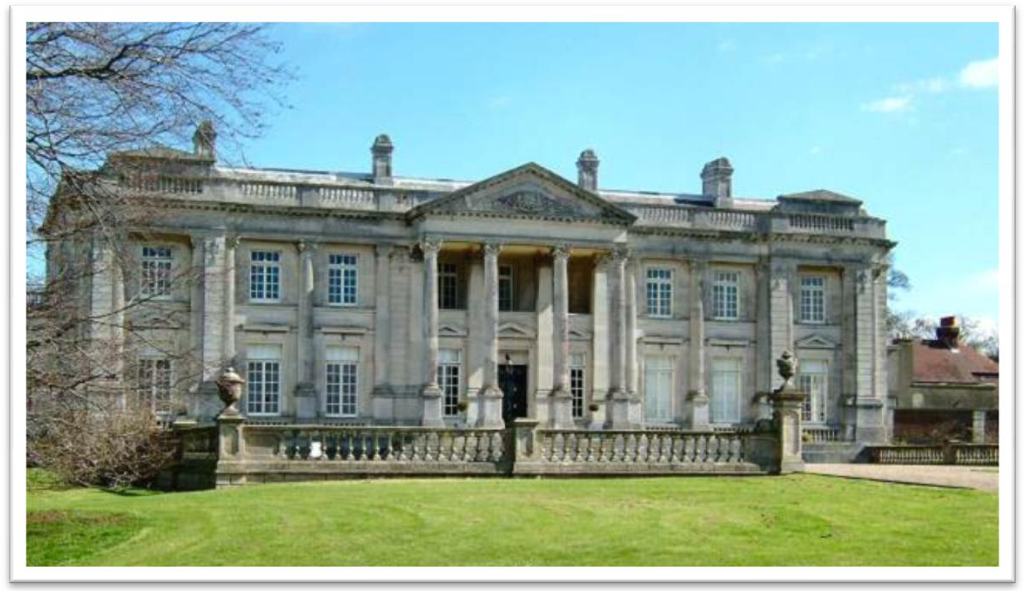

A Dream of Red Mansions



detached house

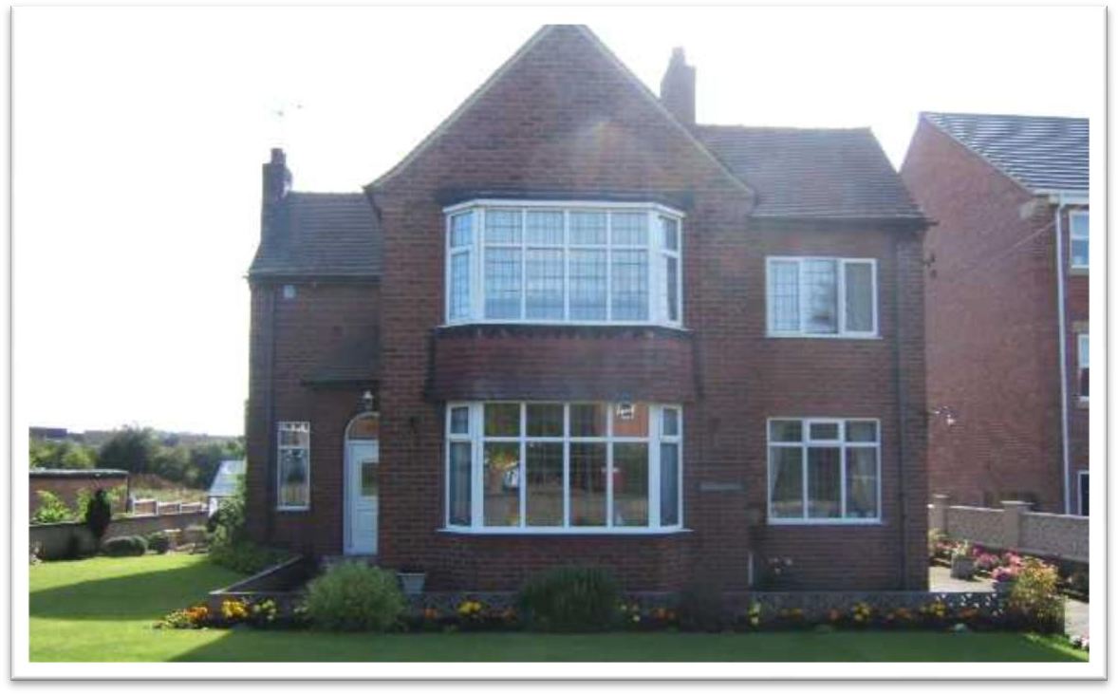

Villa

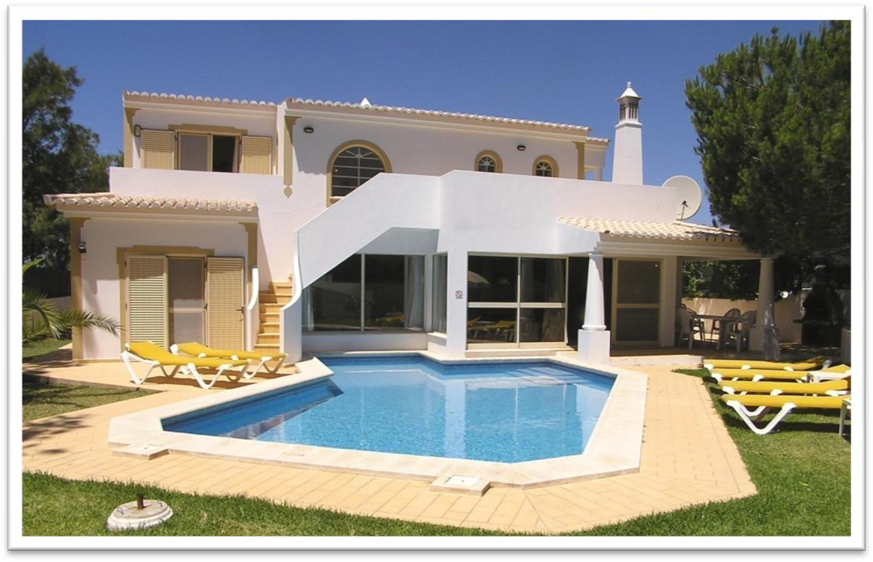

semi-detached house

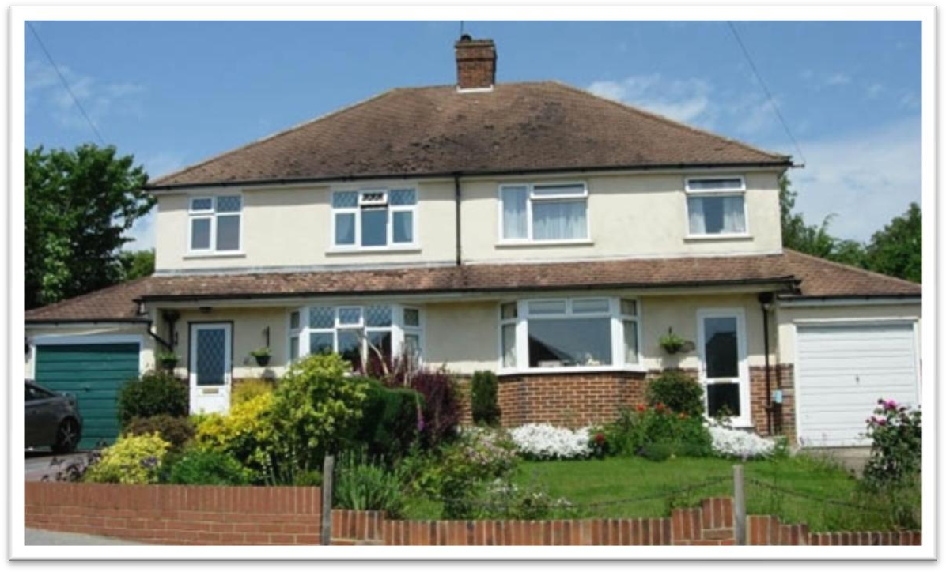

row house / town house

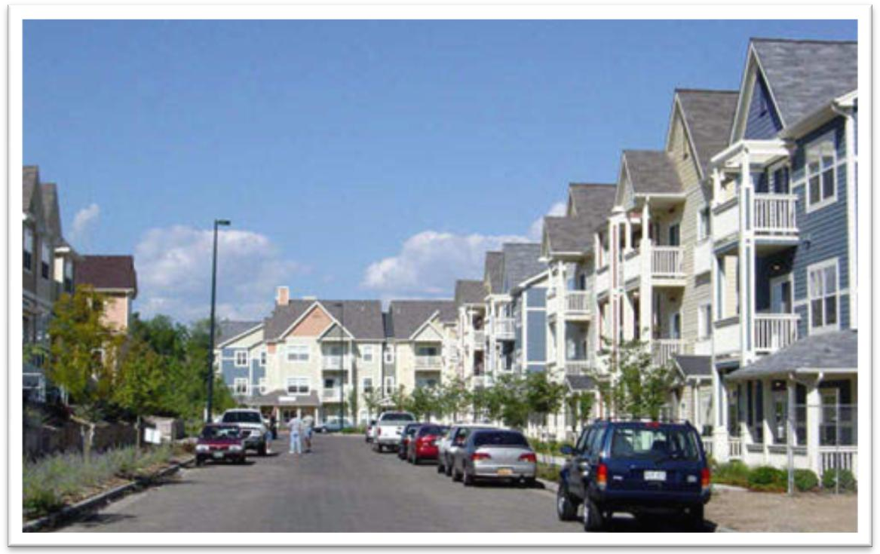

bungalow

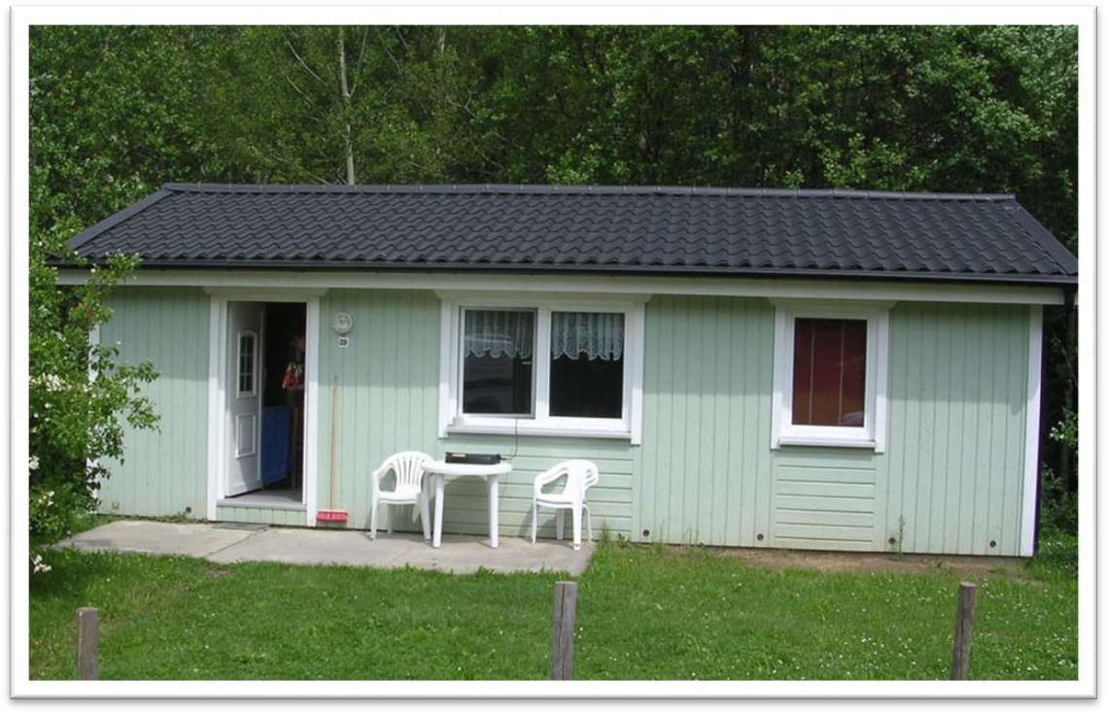

cottage

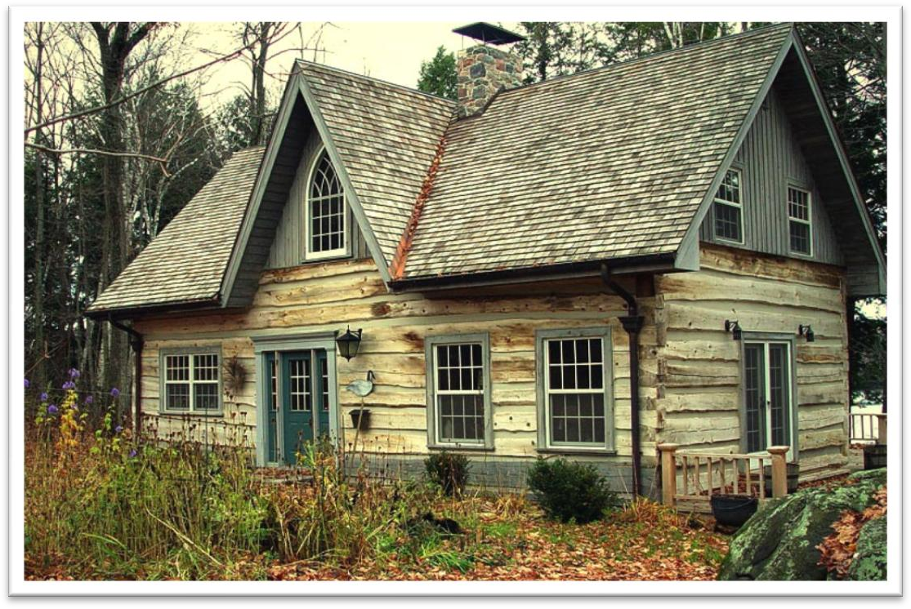

hut

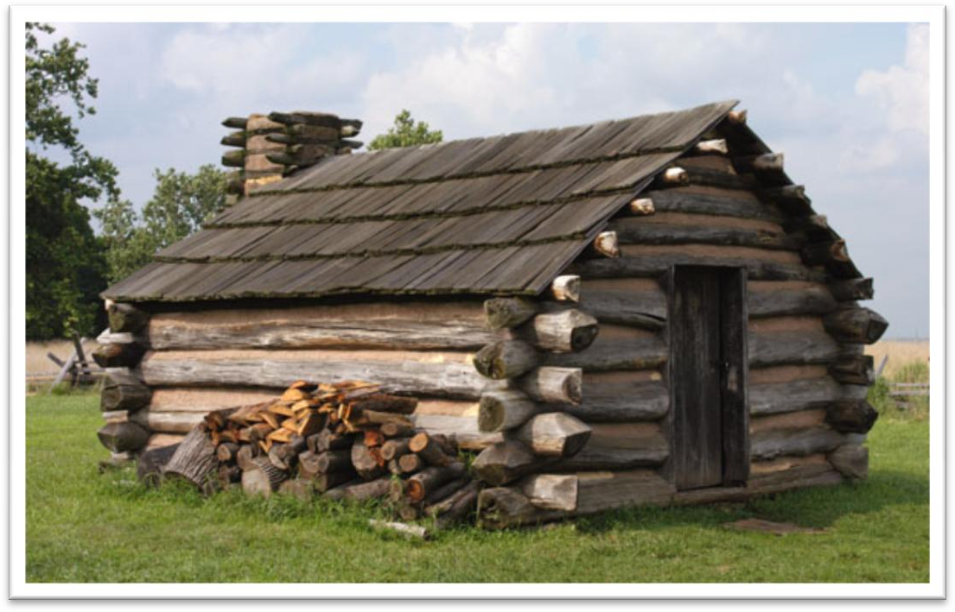

Igloo

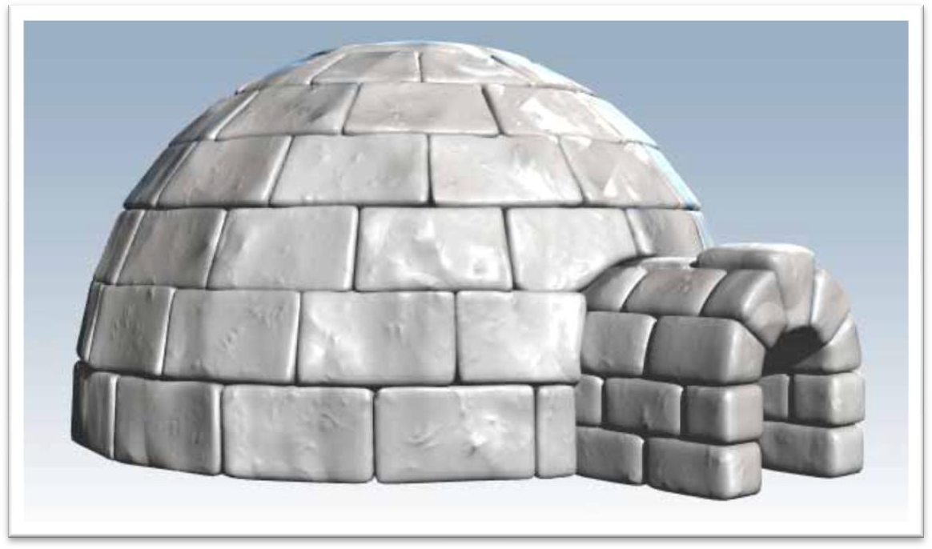

luxury ['lʌkʃəri]

n. 奢侈，豪华；奢侈品

live in luxury / poverty

necessity

Limousines and perfume are luxuries whereas clothing, food, shelter and transportation are basic necessities of daily life.

luxurious fancy luxuriant

luxuriant plants of the tropics deprive [dɪ'praɪv]

v. 剥夺

deprive sb. of sth.

Some criminals are deprived of political rights.

A man without an education, many of us believe, is an unfortunate victim of adverse circumstances, deprived of one of the greatest twentieth-century opportunities.

strip / divest sb. of sth. dispossess sb. of sth.

The nobles were dispossessed of their estates. disinherit sb.

He has disinherited his eldest son.

Hart’s good-bad man was always an outsider, always one of the disinherited, …

deprived disadvantaged underprivileged impoverished destitute

toxic ['tɒksɪk]

adj. 有毒的

toxic chemicals / substances / exhaust fumes

noxious

Carbon monoxide is a colorless, odorless and noxious gas. venomous

venomous snakes / insects

She has beautiful eyes but a venomous tongue. intoxicate

He was thoroughly intoxicated.

He was intoxicated by / with success.

Intoxicated by his success, Harry then asked for perfumed mud. throng [θrɒŋ]

v. 挤满人

Tourists thronged the Imperial Palace.

be thronged / crowded / packed with …

The streets were thronged / crowded / packed with Christmas shoppers. be swarming / teeming with …

The campus was swarming / teeming with students.

Alexis Carrel

**French surgeon and Nobel laureate**

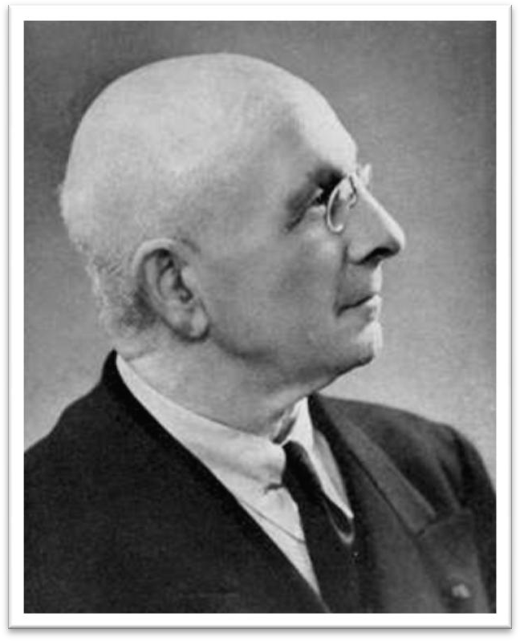

**The text is an excerpt from ‘Man the Unknown’. Alexis wrote ‘Man the Unknown’ in 1935,expounding his elitist philosophy.**

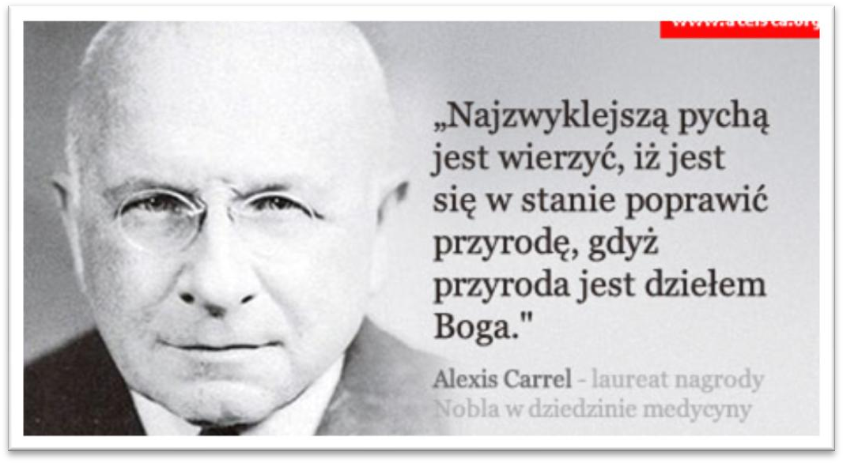

In the organization of industrial life the influence *of the factory upon the*

*physiological and mental state of the workers* has been completely neglected.

in sth. / doing sth.

In seeking independence, they do not sacrifice their human dignity. in return / reward for …

in appreciation of …

I sent him a present in return for / in reward for / in appreciation of his help.

in recognition of …

He was awarded one of the ‘Ten Outstanding Young Persons’ in recognition of his significant achievements.

in honor of …

The college was named in honor of George Washington. a banquet in honor of the president

in memory of …

He wrote a long poem in memory of his late wife. industrial

industrious adj. diligent

… the influence has been neglected … the influence of … on / upon …

the influence of parents on / upon their children the effect of … on / upon …

the effect of fertilizers on / upon the crops the impact of … on / upon …

the impact of the oil spill on / upon marine life devotion / dedication to …

a teacher’s devotion / dedication to his work loyalty / allegiance to…

swear an oath of loyalty / allegiance to the queen love / affection for …

zest / passion / enthusiasm for … pity / compassion / sympathy for … topic sentence

supporting sentences

Modern industry is based on the conception of the maximum production

at lowest cost, in order that an individual or a group of individuals may

earn as much money as possible. conception conceive concept increase production

increase the amount of production

promote the cause of peaceful reunification accelerate the speed of economic reform elevate the living standards for the people

With experience, and with improved apparatus, it is now possible not only to locate a shoal but to tell if it is herring, cod, or other well-known fish, by the pattern of its echo.

with experience √

with accumulating experience X with time √

with passing time X with seasons √

with changing seasons X

the boss board of directors for sb. to do

…, for an individual or a group of individuals to earn as much money as possible.

It has expanded without any idea of the true nature of the human beings who run the machines, and without giving any consideration to the effects

produced on the individuals and on their descendants *by the artificial mode of existence imposed by the factory*.

expand v. to become larger in size, number or amount contract

expand business / one’s chest

The eagle expanded its wings. stretch

The forest stretched all the way to the horizon. He yawned and stretched.

stretch one’s legs

You can stretch your legs on the spacious decks, … dilate

dilated pupils

The medicine will dilate blood vessels. inflate

He used a bicycle pump to inflate the ball. inflation

magnify

This microscope will magnify objects up to 100 times. magnifying glass

amplify

The sound is amplified.

The signals are amplified. amplifier

… without giving any consideration to the true nature of human beings …

… totally neglecting the true nature of human beings … physiological and mental state

physical and spiritual well-being give consideration to …

give thought to … give rise to …

This can give rise to curious situations, as it did in the case of Alfred Bloggs who worked as a dustman for the Ellesmere Corporation.

give birth to … give way to …

Steam trains gave way to electric trains.

What a relief it was when the boulders suddenly disappeared, giving way to a stretch of plain where the only obstacles were clumps of bushes.

give credit to …

The shop gives credit to its customers. mode n. particular way or manner mode of life / existence / thought

Set the monitor to 256 color mode. neglect …

without any idea of …

without giving any consideration to … with no regard for …

The shape and dimensions of the skyscrapers depend entirely on the necessity of obtaining the maximum income per square foot of ground, and of offering to the tenants offices and apartments *that please them*.

the necessity of doing sth.

The report stresses the necessity of eating plenty of fresh fruit and vegetables.

The report stresses that it is necessary to eat plenty of fresh fruit and vegetables.

out of necessity

Women increasingly went out to work, usually out of economic necessity. be a necessity

For most people, a good guide book is a necessity when traveling. be a must

Move to a cheaper apartment.

Find a person to share their apartment.

Hire a new worker.

Write an accurate description of a friend.

W1: What we need is a roommate who is neat and considerate. W2: Let’s write that in the ad: neat-ness and consideration a must.

What do the speakers hope to do?

Answer: (B) Find a person to share their apartment. compulsory

a compulsory course

an optional / elective course

There are no 'illiterates' —if the term can be applied to peoples without a script—while our own compulsory school attendance became law in Germany in 1642, in France in 1806, and in England in 1876, and is still non-existent in a number of 'civilized' nations.

offer sth. to sb.

mass n. throng; a large crowd a mass / throng of people mass education

mass media

weapons of mass destruction problems of mass unemployment

While they enjoy the comfort and banal luxury of their dwelling, they do not realize *that they are deprived of the necessities of life*.

Although / Though they enjoy the …..

While the quality of legal journalism varies greatly, there is an undue reliance amongst many journalists on interpretations supplied to them by lawyers.

While comment and reaction from lawyers may enhance stories, it is

preferable for journalists to rely on their own notions of significance and

make their own judgments.

my humble dwelling residence / domicile

dwell / dweller

city dwellers

the clean atmosphere, the closeness to nature, the intimacy of people, etc. But city dwellers are deprived of all these valuable things in the concrete jungle.

The modern city consists of monstrous edifices and of dark, narrow streets full of petrol fumes and toxic gases, torn by the noise of the

taxicabs, lorries and buses, and thronged ceaselessly by great crowds. consist of …

be made up of … be composed of … comprise … comprise …

make up … compose … constitute … air pollution

noise pollution

a country torn by war

the problem of overpopulation concluding sentence

for the good of … for the sake of … for the benefit of … in the interest of … on behalf of … topic sentence

supporting sentences concluding sentence

s